Scale Calibration

Issue
Scale weight is off or not taking any weight
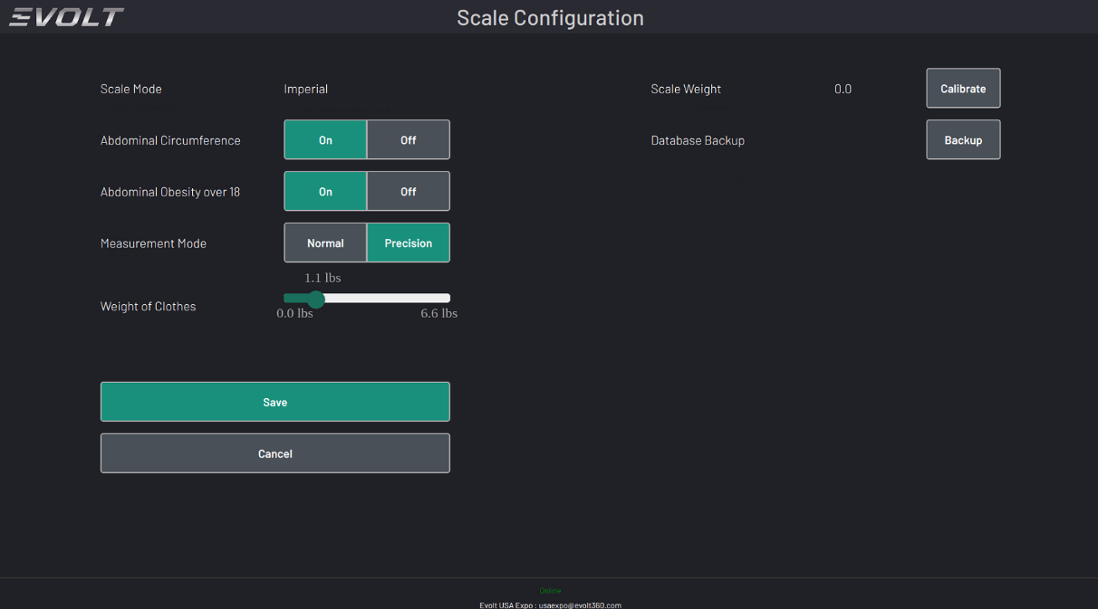
- Check the Scale Settings from the Control Panel by Pressing the EVOLT logo in the upper left corner; then press the Scale Option
- Weight should show 0.0; weight of clothing should be 1.1 lbs or .5 kgs
- Press the “Calibrate” button to reset the Zero and then Press “Save” to save the settings.
- Return to the Scale option; and have the customer use a known weight for accuracy testing. Items such as weight plates or dumbbells carefully placed on the scale are best as body weight can fluctuate.

- Check Initial Readings
  - The Weight should display 0.0.
  - Typical clothing weight should be around 1.1 lbs or 0.5 kgs.
- Calibrate the Scale
  - Press the Calibrate button to reset the zero point.
  - Press Save to apply the calibration settings.
- Test for Accuracy
  - Return to the Scale screen.
  - Use a known weight (e.g., dumbbells or weight plates) to test accuracy.
  - Avoid using body weight for testing, as it can fluctuate.
- Escalation
  - If the scale still shows incorrect readings or fails to detect weight:
    - Escalate the issue to the EVOLT Support Team for further troubleshooting.

